SEG Awards Level 2

Motor Vehicle Studies

Underpinning Knowledge Evidence Record

Y/601/5519 Knowledge of Motor Cycle Internal Engine Systems

Learners Name
SEG Awards Registration Number
Centre Name
Assessor 1 Name
Assessor 2 Name

DECLARATION OF AUTHENTICITY

This declaration must be completed and signed by the learner and countersigned by the tutor / assessor and covers all evidence submitted for moderation.

Learner Name
Unique Learner Number (ULN) |  | SEG  Learner Reg. ID
Qualification Title
Centre Name

Learner statement of authenticity

Before signing please read the guidance below.

I confirm, that the attached assignment / portfolio is all my own work and does not include any work completed by anyone other than myself. I have completed the assignment / portfolio in accordance with SEG Awards’ instructions and within the time limits set by my centre.

Signature |  | Date

Centre confirmation of authenticity

On behalf of …………………………………….(insert centre name), I confirm that the above mentioned learner, to the best of my knowledge, is the sole author of the completed assignment / portfolio attached, and the assessments have been completed under the required conditions.

Signed |  | Date
Name
Title

Guidance for Learners

You have been asked to sign this Declaration of Authenticity and place it at the front of your portfolio or course work assessment. It confirms that the work you have submitted for assessment is your own and that you have not copied it from someone else or allowed another learner to copy it from you.

When preparing any course work it is good practice to undertake research using information from published sources. If you quote directly from these sources then this must be indicated in your work by using quotation marks and referencing the document from which the quotation was taken. You must then comment in your own words on any ideas expressed.

Assessors, internal verifiers and SEG Awards’ external moderators and verifiers are subject specialists who can spot the use of published materials that may be passed as your own words or ideas.
If you do copy words from a published source and do not indicate their reference you will be committing plagiarism. This is considered a form of cheating and may result in your assessment being declared void.

Contents

Task No | Title | Assessment Criteria
1 | Engine components | 1.1, 1.2
2 | Engine configuration | 1.3
3 | Engineering terms | 1.4, 1.5
4 | Engine lubrication | 2.1, 2.2, 2.3, 2.4, 2.5
5 | Cooling systems | 3.1, 3.2, 3.3. 3.5
6 | Clutch and transmission systems | 4.1, 4.2, 4.3.
7 | Powertrain systems | 5.1, 5.2, 5.3, 5.4

Task 1 – Engine components | Assessment Criteria 1.1, 1.2

Label the engine components in the table below
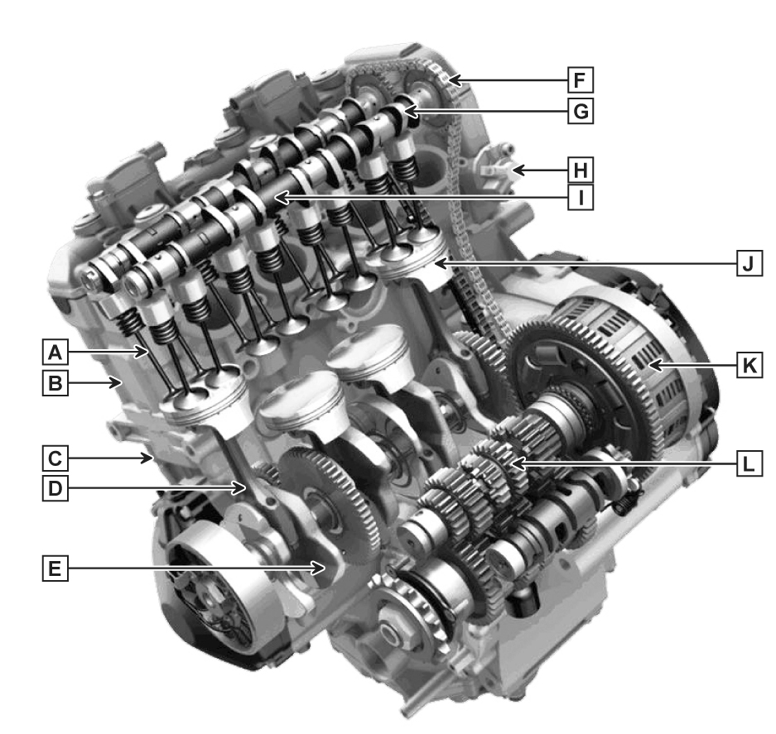
Briefly describe the function of the labelled engine components
Component | Function
A
B
C
D
E
F
G
H
I
J
K
L

Task 2 – Engine configuration | Assessment Criteria 1.3

Investigate THREE engine configurations and complete the table below
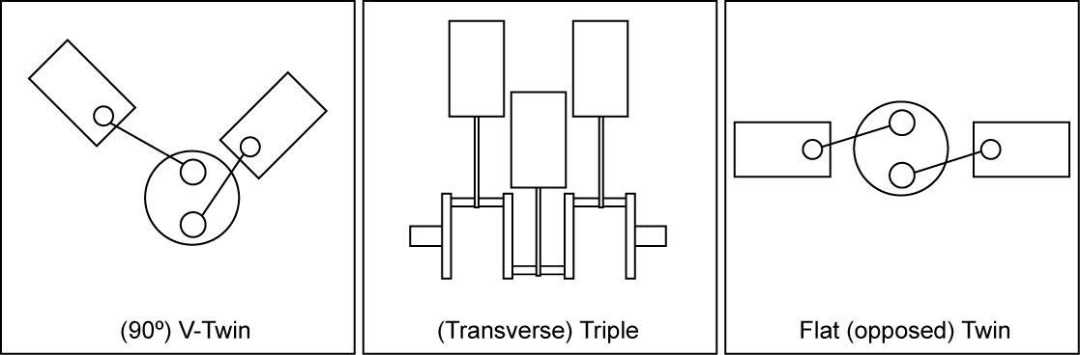
Compare and list differences in operation of;
Transverse (in-line)
Flat (Boxer)
V configuration

Compare the construction and operation of the following engine types
2 Stroke | 4 Stroke

Task 3 – Engineering terms | Assessment Criteria 1.4, 1.5

Describe what is meant by the following engineering terms
Compression ratio
Cylinder capacity (CC)
Power
Torque
TDC
BDC
Stroke
Bore

Task 4 – Engine lubrication | Assessment Criteria 2.1, 2.2, 2.3, 2.4, 2.5

Label the lubrication system components
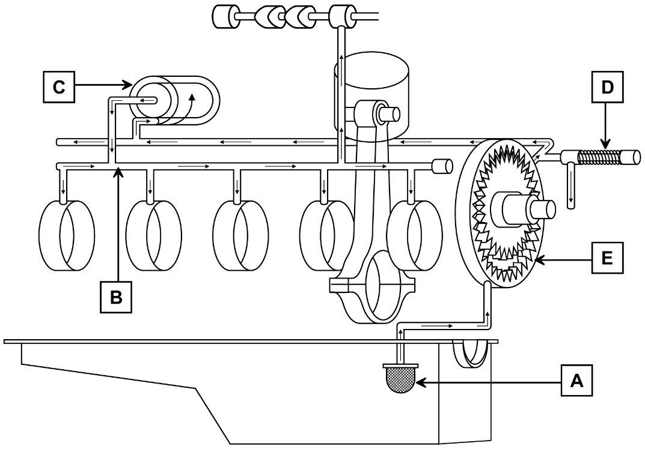

Describe the advantages and disadvantages of wet and dry engine lubrication systems
Wet | Dry | Total Loss

Explain classification of lubricants including properties and methods of reducing friction

Task 5 – Cooling systems | Assessment Criteria 3.1, 3.2, 3.3. 3.5

Label the cooling system components
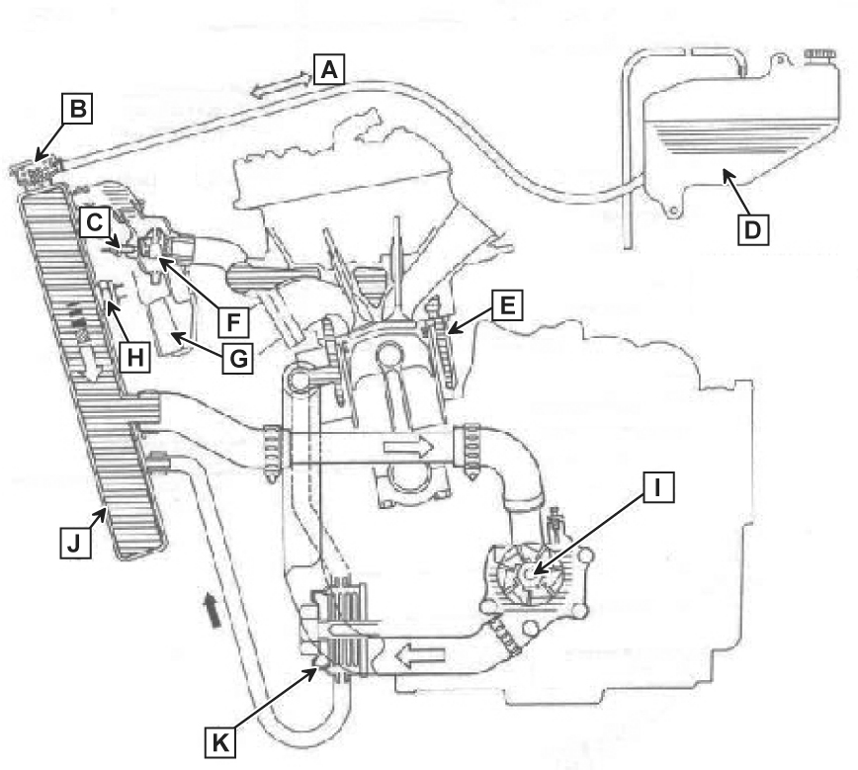
Component
A
B
C
D
E
F
G
H
I
J
K

Describe the advantages and disadvantages of water and air cooling systems
water | Air

Explain the following engineering terms
Heat transfer
Linear and cubical expansion
Specific heat capacity
Boiling point of liquids

Task 6 – Clutch and transmission systems | Assessment Criteria 4.1, 4.2, 4.3.

Identify the labelled motorcycle clutch assembly components below
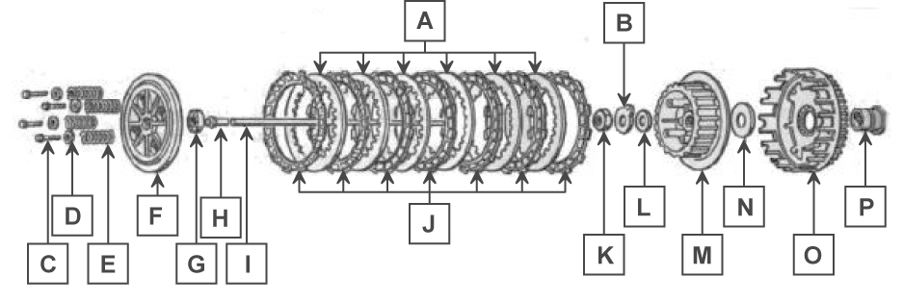
Component
A
B
C
D
E
F
G
H
I
J
K
L
M
N
O
P

Identify and explain the operation of these motorcycle clutch and transmission systems and compare their construction
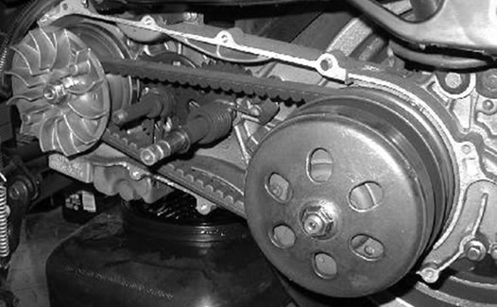
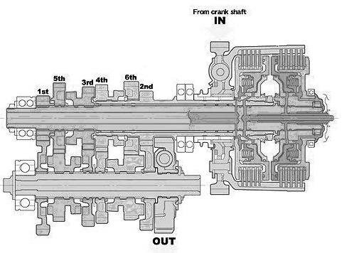
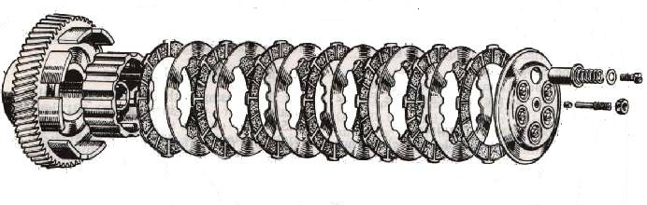

Task 7 – Powertrain systems | Assessment Criteria 5.1, 5.2, 5.3, 5.4

Describe how to remove and replace these powertrain components
Engine
Gearbox
Driveshaft
Drive chain

Describe 2 different methods of testing these powertrain components and the purpose of each test. Include how you would compare against manufacturer specification
 | Test method 1 | Test method 2
Engine
Gearbox
Driveshaft
Drive chain

Give at least 3 examples of common powertrain faults and common causes for each
 | Fault 1 | Fault 2 | Fault 3
Engine
Gearbox
Driveshaft
Drive chain

Unless otherwise stated e.g. for some entry level qualifications, learners can work together but should identify sections which are their own work.

